

**Birth, Not Behavior**

**A Fresh Look at the Prodigal Son**

**Leader’s Guide**

**Introduction**

*Birth, Not Behavior* is about a very important life-changing idea. As we explain on the first page:

*We believe God's unconditional and relentless love for all humans is based on our being created in his image and not on how we behave. We can’t earn his love by being good or lose it by being bad. This is the central message of Jesus’ parable of the prodigal son found in Luke 15. If the title of our book is the tip of the spear, this story is the shaft that drives it home to the heart.*

This simple point is sometimes difficult to get across because most of us assume we know all about the love of God. This assumption acts as a governor that limits our understanding of God’s love. A governor is a mechanical device limiting how fast an engine can go. Metaphorically, we use it to refer to wrong ideas about ourselves and God that hinder our relationship with him.

Likewise, this governor limits their appreciation and experience of grace. It’s common for people to say they believe in God’s grace as undeserved favor, but those same people also believe their behavior makes God pleased or displeased with them. Behavior is important, but it’s not the basis of how God sees and treats us. We must recognize and resist this delusion and embrace our birthright as children of God—his eternal and unchanging love.

Now, a slave has no permanent place in the family,

***but a son belongs to it forever.***

So if the Son sets you free,

you will be free indeed.

John 8:35-36

This book can be studied in four sessions of 50-60 minutes each. There is an Optional Discussion time of up to 30 minutes for sessions that can go 90 minutes. There are time suggestions for each section and handouts for each session. Leaders should read and be familiar with the material before leading the sessions.

**Important:** Ensure participants have the book beforehand and encourage them to read the assigned chapters to get the most out of each session, including the Introduction and first two chapters before session 1.

**Outline**

Session 1

Preface and Introduction

Chapter 1 – The Three Protagonists

Chapter 2 – The Younger Son

The Four Brutal Realities

Session 2

Chapter 3 – The Older Son

The Behavior Spectrum

Session 3

Chapter 4 – The Loving Father

Unconditional Love

Session 4

Chapter 5 – What Happened Next . . .

Afterword

**Session 1**

**Preface and Introduction**

**Chapter 1 – The Three Protagonists**

**Chapter 2 – The Younger Son**

**The Four Brutal Realities**

**Welcome:** (10 minutes)

Greet everyone and provide a book to those who haven’t received one yet. Give a general overview of the four sessions as summarized in the Introduction to *Birth, Not Behavior*. Explain the format and reading schedule. Set a tone that’s warm, friendly, and conversational.

Read the parable of the prodigal son from Chapter 1.

Briefly introduce the three protagonists in the story: Lev, Judah, and Av.

Distribute session 1 handout.

**Group discussion**: (20-30 minutes)

The Four Brutal Realities are universal and unavoidable, although we experience them to different degrees and at different stages in life.

Brutal Reality One: The world does not revolve around you.

Brutal Reality Two: Life is hard.

Brutal Reality Three: You are going to die.

Brutal Reality Four: You are not in control.

1. How did Lev encounter these realities?
2. How have you encountered them?
3. What lessons have you learned from the experience?

**Table time**: (15 minutes)

Divide into table-sized groups and appoint a moderator for each table. Rotate moderators each week. Provide paper and pens for a 10-minute writing time. Use a timing app to keep to the schedule. Say something like:

*“You are free to write whatever you want; don’t worry about how polished your words are. After the time expires, you’ll have the chance to discuss your thoughts with those at your table. Only share what you want; feel free to pass if you wish. There are no expectations, and no one’s recording what’s being shared.”*

The question:

Identify one of the Four Brutal Realities that seems the most prominent in your life right now. What difference would it make in your thinking and behavior if you accepted this reality as something you can’t change?

When the writing time expires, let anyone who wants share what they wrote with their table. (5 minutes)

**Optional Discussion**: (30 minutes)

Bring everyone back together. Go around the group and ask each person to share what they wrote. Make it clear that anyone can pass who doesn’t want to share.

**Closing**: (5 minutes)

Make it personal. Talk about one of the authors’ stories or share one of your own that illustrates what’s being taught in these chapters.

Assignment for session 2: Read Chapter 3.

**Session 2**

**Chapter 3 – The Older Son**

**Behavior Spectrum**

**Welcome:** (5 minutes)

Start on time. Open with some friendly remarks and give everyone the session 2 handout.

**Group discussion**: (20-30 minutes)

Both Lev and Judah had governors on their thinking in the common misconception that behavior overshadowed birth when it came to their relationship with their father. However, they were on opposite ends of the behavior spectrum.

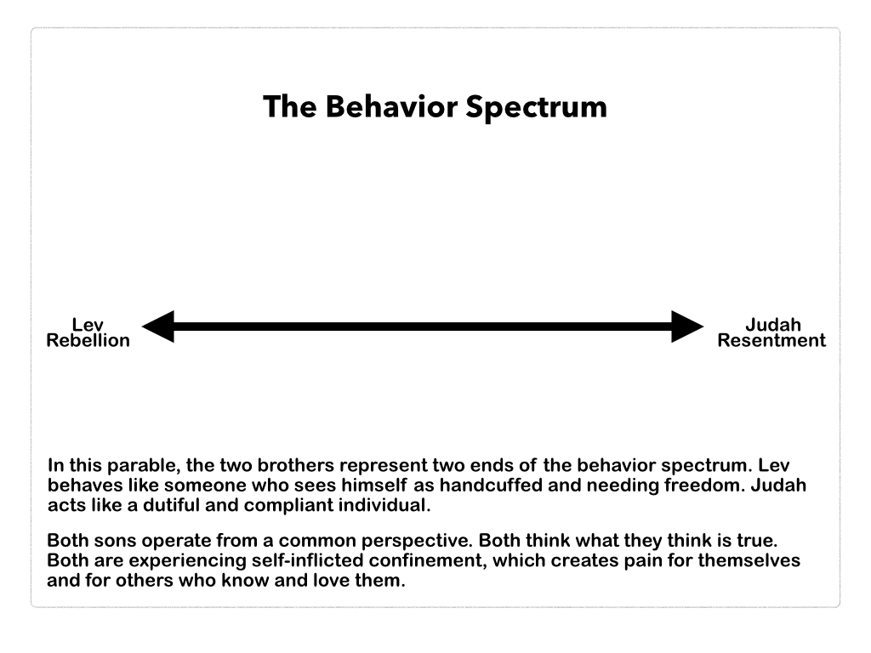

1. What did Lev believe about how his behavior affected his relationship with his father?
2. What did Judah believe about how his behavior affected his relationship with his father?
3. Grace means “unmerited favor,” so why do so many of us feel we have to earn grace by being good or can lose it by being bad?

**Table Time:** (15 minutes)

Divide into table-sized groups and appoint a moderator for each table. Rotate moderators each week. Provide paper and pens for a 10-minute writing time. Use a timing app to keep to the schedule. (10 minutes)

The question:

Which son do you most identify with, Lev or Judah? Where are you on the Behavior Spectrum at this point in your life? How does this affect your relationship with the Father?

When the writing time expires, let anyone who wants share what they wrote with their table. (5 minutes)

**Optional Discussion**: (30 minutes)

Bring everyone back together. Go around the group and ask each person to share what they wrote. Make it clear that anyone can pass who doesn’t want to share.

**Closing**: (5-10 minutes)

Make it personal. Talk about one of the authors’ stories or share one of your own that illustrates what’s being taught in this chapter.

Assignment for session 3: Read Chapter 4.

**Session 3**

**Chapter 4 – The Loving Father**

**Unconditional Love**

**Welcome:** (5 minutes)

Start on time. Open with some friendly remarks and give everyone the session 3 handout.

**Group discussion**: (20-30 minutes)

Av’s unconditional love for his rebellious and resentful sons reflects the heavenly Father’s love for his children.

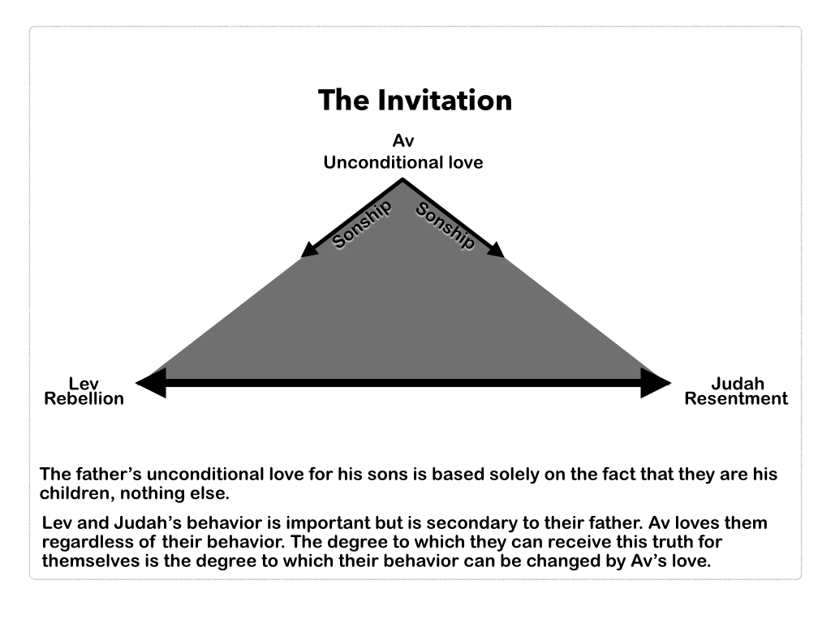

1. What’s surprising and unexpected about Av’s behavior toward Lev and Judah? Which of Av’s actions would have shocked Jesus’ original listeners?
2. What role did Lev’s confession and repentance play in Av’s reception of him? What role do confession and repentance play in our relationship with the Father?
3. How was Av’s treatment of Judah like his treatment of Lev? Do you think Judah eventually joined the celebration? Would you have joined the celebration?

**Table Time:** (15 minutes)

Divide into table-sized groups and appoint a moderator for each table. Rotate moderators each week. Provide paper and pens for a 10-minute writing time. Use a timing app to keep to the schedule. (10 minutes)

Select one question to write about:

If you’re a parent, have you faced situations like Av did with Lev and Judah? If so, how did you respond, and how did it turn out?

As a son or daughter, were you more rebellious or resentful? How did your parents treat you, and how has that affected your relationship with them and God?

In what way does your feeling of being unconditionally loved by God affect how you view and treat other people?

When the writing time expires, let anyone who wants share what they wrote with their table. (5 minutes)

**Optional Discussion**: (30 minutes)

Bring everyone back together. Go around the group and ask each person to share what they wrote. Make it clear that anyone can pass who doesn’t want to share.

**Closing**: (5-10 minutes)

Make it personal. Talk about one of the authors’ stories or share one of your own that illustrates what’s being taught in this chapter.

Assignment for session 4: Read Chapter 5 and the Afterword.

**Session 4**

**Chapter 5 – What Happens Next . . .**

**Afterword**

**Welcome:** (5 minutes)

Start on time. Open with some friendly remarks and give everyone the session 4 handout.

**Group discussion**: (20-30 minutes)

Discuss as many of these questions as you have time for. Select the order of the questions in advance based on your knowledge of the group.

1. Jesus left his parable open-ended. What do you imagine happened to Av’s family? Did Lev’s experience permanently change him? Did Judah ever forgive Lev? Was the rift between them ever healed?
2. Should repentance be required before restoring someone to a family or church community? Should an “I’m sorry” be accepted as soon as it is offered, or should it be tested over time to see if it’s genuine?
3. The Afterword lists twenty verses that imply God’s love and forgiveness will be experienced by all humans, even though the “how to” is unclear. To what degree do you believe God’s love extends to all people, regardless of their beliefs or behavior? In other words, is his love unconditional?

**Table Time:** (15 minutes)

Divide into table-sized groups and appoint a moderator for each table. Rotate moderators each week. Provide paper and pens for a 10-minute writing time. Use a timing app to keep to the schedule. (10 minutes)

The question:

We have spent four weeks discussing God’s unconditional love for all his children. How has this changed the way you think God thinks about you? How has it changed the way you think about him? How has it changed the way you think about others?

When the writing time expires, let anyone who wants share what they wrote with their table. (5 minutes)

**Optional Discussion**: (30 minutes)

Bring everyone back together. Go around the group and ask each person to share what they wrote. Make it clear that anyone can pass who doesn’t want to share.

**Wrap up**: (10-15 minutes)

Read these closing comments, then ask how studying this parable has impacted people’s thinking about the love of God.

As we embrace what is true about us as God’s children—we are loved, regardless—our behavior will change. Believing this truth will have a dramatic effect on our behavior. We are safe! Therefore, we are free to honestly assess ourselves, the good, the bad, and the ugly, without fear of being rejected. We can face our faults and failures without the fear that they will cause the father to be angry with us or reject us.

Because we are unconditionally loved, we are free to acknowledge and let go of the things that are harmful to us. These include wrong beliefs about God and ourselves and certain behaviors we think will make us more acceptable to God. This freedom of knowing we are unconditionally loved is what brings about changes in our behavior. Our focus shifts from EARNING God’s love to ENJOYING God’s love.

“So if the Son sets you free, you will be free indeed.”

John 8:36.

**HANDOUTS**

**Session 1**

**Preface and Introduction**

**Chapter 1 – The Three Protagonists**

**Chapter 2 – The Younger Son**

**The Four Brutal Realities**

**Group discussion**:

The Four Brutal Realities are universal and unavoidable, although we experience them to different degrees and at different stages in life.

Brutal Reality One: The world does not revolve around you.

Brutal Reality Two: Life is hard.

Brutal Reality Three: You are going to die.

Brutal Reality Four: You are not in control.

1. How did Lev encounter these realities?
2. How have you encountered them?
3. What lessons have you learned from the experience?

**Table time**:

Divide into table-sized groups and appoint a moderator for each table. Rotate moderators each week. Provide paper and pens for a 10-minute writing time. Use a timing app to keep to the schedule.

The question:

Identify one of the Four Brutal Realities that seems the most prominent in your life right now. What difference would it make in your thinking and behavior if you accepted this reality as something you can’t change?

**Session 2**

**Chapter 3 – The Older Son**

**Behavior Spectrum**

**Group discussion**:

Both Lev and Judah had governors on their thinking in the common misconception that behavior overshadowed birth when it came to their relationship with their father. However, they were on opposite ends of the behavior spectrum.

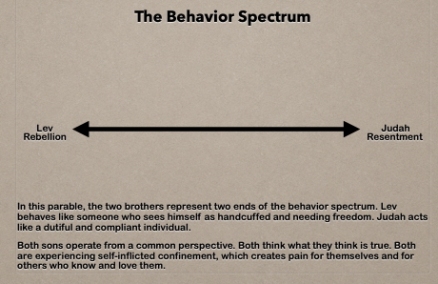

1. What did Lev believe about how his behavior affected his relationship with his father?
2. What did Judah believe about how his behavior affected his relationship with his father?
3. Grace means “unmerited favor,” so why do so many of us feel we have to earn grace by being good or can lose it by being bad?

**Table Time:**

Divide into table-sized groups and appoint a moderator for each table. Rotate moderators each week. Provide paper and pens for a 10-minute writing time. Use a timing app to keep to the schedule.

The question:

Which son do you most identify with, Av or Judah? Where are you on the Behavior Spectrum at this point in your life? How does this affect your relationship with the Father?

Learn more about The Behavior Spectrum on the Christ in the Rockies website.

QR code

**Session 3**

**Chapter 4 – The Loving Father**

**Unconditional Love**

**Group discussion**:

Av’s unconditional love for his rebellious and resentful sons reflects the heavenly Father’s love for his children.

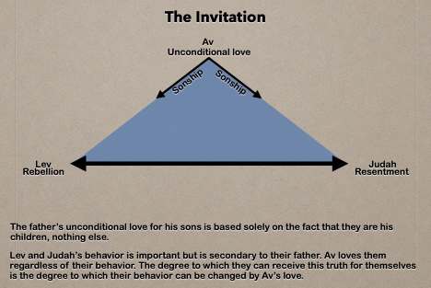

1. What’s surprising and unexpected about Av’s behavior toward Lev and Judah? Which of Av’s actions would have shocked Jesus’ original listeners?
2. What role did Lev’s confession and repentance play in Av’s reception of him? What role do confession and repentance play in our relationship with the Father?
3. How was Av’s treatment of Judah like his treatment of Lev? Do you think Judah eventually joined the celebration? Would you have joined the celebration?

**Table Time:**

Divide into table-sized groups and appoint a moderator for each table. Rotate moderators each week. Provide paper and pens for a 10-minute writing time. Use a timing app to keep to the schedule.

Select one question to write about:

If you’re a parent, have you faced situations like Av did with Lev and Judah? If so, how did you respond, and how did it turn out?

As a son or daughter, were you more rebellious or resentful? How did your parents treat you, and how has that affected your relationship with them and God?

**Session 4**

**Chapter 5 – What Happens Next . . .**

**Afterword**

**Group discussion**:

Discuss as many of these questions as you have time for.

1. Jesus left his parable open-ended. What do you imagine happened to Av’s family? Did Lev’s experience permanently change him? Did Judah ever forgive Lev? Was the rift between them ever healed?
2. Should repentance be required before restoring someone to a family or church community? Should an “I’m sorry” be accepted as soon as it is offered, or should it be tested over time to see if it’s genuine?
3. The Afterword lists twenty verses that imply God’s love and forgiveness will be experienced by all humans, even though the “how to” is unclear. To what degree do you believe God’s love extends to all people, regardless of their beliefs or behavior? In other words, is his love unconditional?

**Table Time:**

Divide into table-sized groups and appoint a moderator for each table. Rotate moderators each week. Provide paper and pens for a 10-minute writing time. Use a timing app to keep to the schedule.

The question:

Will the redemptive work of Jesus Christ triumph over defiant human will or satanic interference? Based on what Jesus taught in the Parable of the Prodigal Son, what do you think?

**Wrap-up:**

As we embrace what is true about us as God’s children—we are loved, regardless—our behavior will change. Believing this truth will have a dramatic effect on our behavior. We are absolutely safe! Therefore, we are free to honestly assess ourselves, the good, the bad, and the ugly, without fear of being rejected. We can face our faults and failures without the fear that they will cause the father to be angry with us or reject us.

Because we are unconditionally loved, we are free to acknowledge and let go of the things that are harmful to us. These include wrong beliefs about God and ourselves and certain behaviors we think will make us more acceptable to God. This freedom of knowing we are unconditionally loved is what brings about changes in our behavior. Our focus shifts from EARNING God’s love to ENJOYING God’s love.

“So if the Son sets you free, you will be free indeed.”

John 8:36.